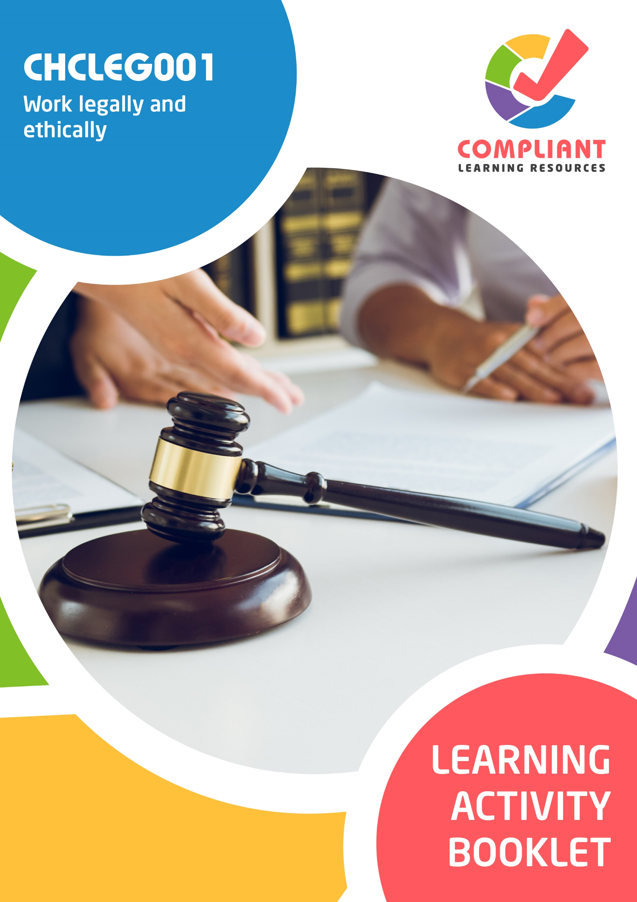

**Copyright**

This document was developed by Compliant Learning Resources.

© 2022 Compliant Learning Resources.

All rights reserved.

No part of this publication may be reproduced, stored in a retrieval system, or transmitted in any form or by any means, electronic, mechanical, photocopying, recording, or otherwise without the prior written permission of Compliant Learning Resources.

**Version Control & Document History**

|  |  |  |
| --- | --- | --- |
| **Date** | **Summary of Modifications** | **Version** |
| 13 May 2022 | Version 1.0 released for publishing | 1.0 |

# Table of Contents

Overview 4

Learner Instructions 5

Learner Information 5

Trainer Information 5

Resources Required 6

Work Health and Safety 6

Reasonable Adjustment 7

Formative Activities 8

I. Identify and Respond to Legal Requirements 8

Activity 1.1 8

Activity 1.2 9

Activity 1.3 10

II. Identify and Meet Ethical Responsibilities 11

Activity 2.1 11

Activity 2.2 12

III. Contribute to Workplace Improvements 13

Activity 3.1 13

Activity 3.2 14

Activity 3.3 15

# Overview

**CHCLEG001 - Work legally and ethically (Release 1)**

This unit describes the skills and knowledge required to identify and work within the legal and ethical frameworks that apply to an individual job role.

This unit applies to community services and health workers who play a proactive role in identifying and meeting their legal and ethical responsibilities.

**A complete copy of the above unit of competency can be downloaded from the TGA website:**

[https://training.gov.au/training/details/CHCLEG001](https://training.gov.au/training/details/chcleg001)

# Learner Instructions

This Learning Activity Booklet contains formative activities that learners will complete in the classroom or a similar environment.

These formative activities include knowledge questions to test your underpinning generic knowledge and practical activities to test your skills relevant to the unit/s of competency.

These formative assessments are used by your trainer to complement both the learning and training processes, and to evaluate how you are progressing throughout these processes.

You may reference your Learner Guide and other learning materials to complete the activities included in this workbook.

**IMPORTANT:**

**The completion of the formative assessments and learning activities included in this workbook DOES NOT lead to a Qualification or a Statement of Attainment (SOA).**

## Learner Information

|  |  |
| --- | --- |
| Learner name |  |
| Phone |  |
| Email |  |

## Trainer Information

|  |  |
| --- | --- |
| Trainer name |  |
| RTO name |  |
| RTO phone |  |
| RTO email |  |

# Resources Required

Resources needed to complete activities included in this workbook include:

* Computer with Internet, email access, and a working web browser
* Installed software: MS Word, Adobe Acrobat Reader
* Learner guide
* A volunteer to participate in a role play activity

# Work Health and Safety

Both the trainers and learners have duty of care in ensuring that the learning environment is free from hazards that may pose risks to their health and safety.

According to WHS legislation, trainers and learners must take reasonable care while undertaking the activities included in this workbook in the learning environment.

# Reasonable Adjustment

‘Reasonable adjustment’ in VET is the term applied to modifying the learning environment or making changes to the training delivered to assist a learner with a disability. A reasonable adjustment can be as simple as changing classrooms to be closer to amenities or installing a particular type of software on a computer for a person with vision impairment.

**Why make a reasonable adjustment?**

We make reasonable adjustments in VET to make sure that learners with disabilities have:

* The same learning opportunities as learners without disabilities, and
* The same opportunity to perform and complete assessments as those without disabilities.

**Reasonable adjustment applied to participation in teaching, learning, and assessment activities can include:**

* Customising resources and assessment activities within the training package or accredited course
* Modifying the presentation medium
* Learner support
* Use of assistive/adaptive technologies
* Making information accessible both before enrolment and during the course
* Monitoring the adjustments to ensure learner needs continue to be met

**Assistive/Adaptive Technologies**

Assistive/adaptive technology means ‘software or hardware that has been specifically designed to assist people with disabilities in carrying out daily activities’ (World Wide Web Consortium - W3C). It includes screen readers, magnifiers, voice recognition software, alternative keyboards, devices for grasping, visual alert systems, and digital note-takers.

*(Adapted Reasonable Adjustment in teaching, learning and assessment for learners with a disability - November 2010 - Prepared by - Queensland VET Development Centre)*

**IMPORTANT:**

**Reasonable adjustment made for collecting learner assessment evidence must not impact the standard expected by the workplace, as expressed by the relevant unit/s of competency. For example, if the assessment were gathering evidence of the learner’s competency in writing, allowing the learner to complete the assessment verbally would not be a valid assessment method. The method of assessment used by any reasonable adjustment must still meet the competency requirements.**

# Formative Activities

## I. Identify and Respond to Legal Requirements

### Activity 1.1

|  |  |  |  |  |  |  |  |
| --- | --- | --- | --- | --- | --- | --- | --- |
| **Matching Type**  Identify the common terms used in legislation being described in each statement below.   |  | | --- | | **Common Terms Used in Legislation** | | Act | | Amendment | | Bill | | Commencement | | Preamble | | |
|  | |
| Description | |
|  | 1. It sets out the reasons for and scope of a law. |
|  | 1. It is a change to the law generally made by another law. |
|  | 1. It is the time/date at which a law comes into force. |
|  | 1. It is a draft Act of Parliament. |
|  | 1. It is a statute or law passed by both Houses of Parliament that has received Royal Assent. |

### Activity 1.2

|  |
| --- |
| **Fill in the blanks**  The following are statements about ways of responding to legal issues. Review each and complete the statement by filling in the missing words/phrases. |
|  |
| 1. When you consult a      , they can give you legal counsel and the proper approach to sort out an issue. |
| 1. is a similar process to negotiation but a neutral person, called the      , is involved. The neutral person should not be biased towards any people involved. Their role is to guide parties in reaching an agreement |
| 1. is a process where the neutral person, called the      , makes a decision. The neutral person listens to both parties and decides how to resolve the issue. Both parties should comply with the neutral person’s decision. |
| 1. You can resolve legal issues through      , such as negotiation and mediation. |
| 1. is a process of taking the legal issue to court. At the end of this process, a judge will make a decision on how the issue should be resolved. |

### Activity 1.3

|  |
| --- |
| **SCENARIO**  The first responder answered an emergency call. It was from a mother. She said that her child fainted.  When the responder arrived at the scene, he evaluated the situation. There were no hazards that posed risks to anyone in the area. He assessed the unconscious child. The child needed cardiopulmonary resuscitation (CPR).  Before the treatment, the first responder asked for the mother’s consent. He explained the procedure and the need for it. The mother understood and gave him her consent. He then proceeded to do CPR. |

|  |
| --- |
| What legal requirement did the first responder adhere to in the scenario? |
|  |
|  |

## II. Identify and Meet Ethical Responsibilities

### Activity 2.1

|  |  |
| --- | --- |
| **Matching Type**  Listed below are ethical issues occurring in the workplace.   1. Discrimination 2. Harassment 3. Conflict of interest 4. Neglect 5. Breach of privacy and confidentiality.   Match each to their description below, by writing the letter that corresponds to your answer in the space provided. | |
|  | |
| Description | |
|  | 1. It means giving unfair treatment to people due to their identity or characteristics. |
|  | 1. This instance occurs when someone’s personal interests may affect their ethical judgment. |
|  | 1. It refers to the failure to care for a person adequately. |
|  | 1. This instance occurs when personal information are accessed by other unauthorised people. |
|  | 1. It involves unwanted actions that offend, intimidate, or humiliate another person. |

### Activity 2.2

|  |
| --- |
| List five sources of ethical responsibilities in the workplace. |
|  |
|  |
|  |
|  |
|  |
|  |

## III. Contribute to Workplace Improvements

### Activity 3.1

|  |
| --- |
| **Fill in the blanks**  The following are statements related to meeting legal and ethical responsibilities. Review each and complete the statement by filling in the missing words/phrases. |
|  |
| 1. responsibilities are anchored in the existing laws. |
| 1. Universal moral values guide       responsibilities. |
| 1. You can       work practices by observing how policies are implemented in the workplace. |
| 1. You can       to determine your colleagues’ stand on company policies and procedures. |
| 1. You can obtain       from the client to help improve work practices and to better meet legal and ethical responsibilities. |

### Activity 3.2

|  |  |
| --- | --- |
| **True or False**  Review the statements below about developing policies and protocols. Indicate whether each statement is True or False.  Tick the box that corresponds to your answer. | |
|  | |
| TRUE  FALSE | 1. The first step in developing policies and protocols is to identify the need for one. |
| TRUE  FALSE | 1. Research is not a part of the development process for policies and protocols. |
| TRUE  FALSE | 1. Stakeholders should be consulted during the development of policies and protocols. |
| TRUE  FALSE | 1. There is no need to make a draft when developing policies and protocols. |
| TRUE  FALSE | 1. The goal of developing policies and protocols is to implement them in the workplace. |

### Activity 3.3

|  |
| --- |
| **SCENARIO**  You received feedback from a parent regarding the safety of the school’s playground. You know that sharing the feedback to your colleagues will help the school improve its policies and practice. You decided to set up a meeting with your supervisor to discuss the feedback you received. |

|  |
| --- |
| **Role Play Activity**  Role play the scenario with a volunteer to discuss the feedback about the safety of the school’s playground, while demonstrating the practical skills listed in the checklist below.  Perform this activity while being observed by your trainer. If your trainer is not available to directly observe you, you may video record the role play activity and submit the recording to your trainer.  **Your role**  For this activity, you will take the role of the education support worker.  **The volunteer’s role**  For this activity, the volunteer will take the role of the supervisor. |

|  |  |  |
| --- | --- | --- |
| **Role Play Checklist** (For trainer’s use only) | | |
| **During the role play activity:** | **YES** | **NO** |
| 1. The learner verbally relays the feedback to the supervisor. |  |  |
| 1. The learner discusses how the feedback affects the clients (students and parents). |  |  |
| 1. The learner discusses how the feeback affects the employees. |  |  |
| 1. The learner discusses how the feedback affects the organisation (school). |  |  |
| 1. The learner suggests on what can be done about the feedback. |  |  |
| Trainer’s overall feedback on the learner’s performance during the role play activity: | | |

End of Document